Assignment on Computer Network LAB

1. General Idea about Different types of servers.
2. Connecting Laptop and printer to a network
3. Implement and Configure the following network using packet tracer.

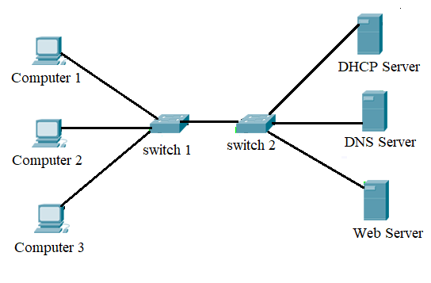

Create VLAN for the following scenario

1. Implement the following network topology using Cisco Packet Tracer.

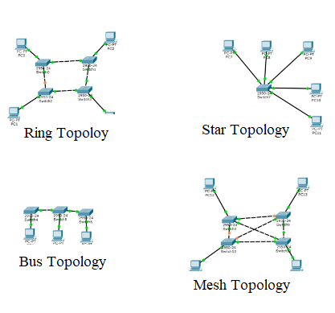

1. Dynamic NAT, ACL implementation

Before applying any ACLs to a network it is important to confirm that we have full connectivity. Verify, that the network has fully connectivity by choosing a PC and pinging other devise on the network.

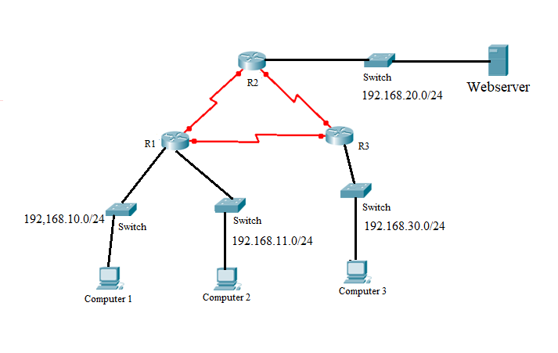

The following network policies are implemented on R2

* The 192.168.11.0/24 network is not allowed access to the Webserver on the 192.168.20.0/24 network.
* All other access is permitted.

To restrict access from the 192.168.11.0/24 network to the Web Server 192.168. 20.254 without interfering with other traffic, an ACL must be created on R2. The access list must be placed on the outbound interface to the webserver. A second rule must be created on R2 to permit all other traffic.

* Create an ACL using the number 1 on R2 with statement that denies access to the 192. 168. 11 .0/24 network.

R2(config) # access-list deny192.168.11.0/24 0.0.0.255

1. Implement the following network topology using packet tracer. Create two VLANs.

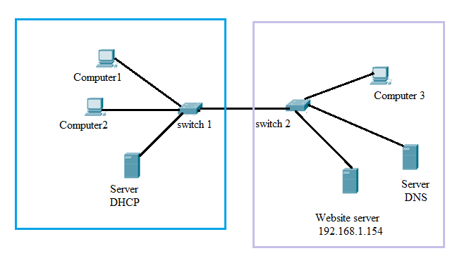

1. Static NAT: Change Local Address of ISP Router to global address of DNS server of Internet to Global Address 50.0.0.1.

